How to differ common cold (URTI) from pneumonia
Common cold/URTI – no antibiotics |  | Pneumonia – antibiotics
Virus. Antibiotics useless.  Normal children have 6-7 common colds a year and an adult 2-3.  Symptoms:  Cough  Running nose  Fever  Soar throat  Not so sick  3-5 days but can last longer  Treatment:  Symptomatic (paracetamol, nasal drops, cough syrup) |  | Bacteria. Antibiotic is needed.  Symtoms:  Cough  Increased respiratory rate  Respiratory distress  High fever  More sick-looking  Chest wall indrawings and nasal flaring on small children  Crepitations often heard when examining the lungs  Treatment: Antibiotics and symptomatic treatment  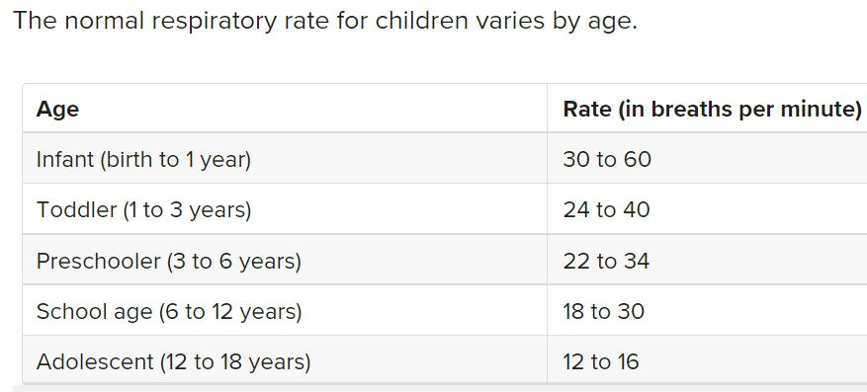

Gastroenteritis
According to Kenyan Basic Paediatric Protocols for ages up to 5 years: “Antimicrobials are not indicated unless there is dysentery or proven amoebiasis or giardiasis.”
Shigella-dysentery: Bloody diarrhea. Ciprofloxacin.
Amoebiasis: More sick. Abdominal discomfort. Can be bloody. Metronidazol.
Giardiasis: Watery diarrhea, abdominal cramping. Metronidazol.

/Åsa Lundgren, Rotary Doctors’, Sweden, June 2024

